42G1 - A ‘survivor’ by David G Davis

The 80th Anniversary of the introduction of the Twenty Horsepower in October 1922 is an appropriate time to review the service history of an early car over all those years.
42G1, my own car since 1959, is perhaps, appropriate as the records are fairly complete and it was the first to arrive in Australia.
The car left the factory on 19th December 1922 and was shipped on the SS Diogenes ( its maiden voyage ) from London to Sydney, arriving in March 1923. Dalgety’s had Smith & Waddington fit a box seat (body no 1) to 42G1 and it was used as a trials car (demonstrator). Late in 1923 Col.John Arnott bought the car and had Smith & Waddington fit a two door four seater saloon body (body no 2). It was to be Mrs Arnott’s however it became the family hack
A set of new front springs were fitted together with extra leaves in March 1924.New brake ropes, starter bendix drive and tappet covers were fitted together with new battery box stays and warning plate later in that year. Col. Arnott also bought various tools and spares. During this time, the shutters and undertray were removed to reduce overheating of the engine. During 1925 the only recorded problem seemed to be a rattle from the dynamo drive, a problem I was to further address in the 1960’s.
Late in 1925, the car was involved with a stone wall and as a result, a new chassis was fitted together with new front axle, steering column and steering tubes. Smith & Waddington rebuilt the body into a four door four seater saloon (body no 3) the only major part of the previous body retained was the instrument board and the scuttle.
1927 and 1928 seemed to be uneventful however 1929 resulted in another serious accident ,this time involving a steam wagon, and again a new chassis , steering tubes , a new lower half of the crankcase, off side engine guard , new bonnet hinges together with 21 inch well base wheels and front hydraulic shock absorbers were fitted. The body was repaired rather than altered.
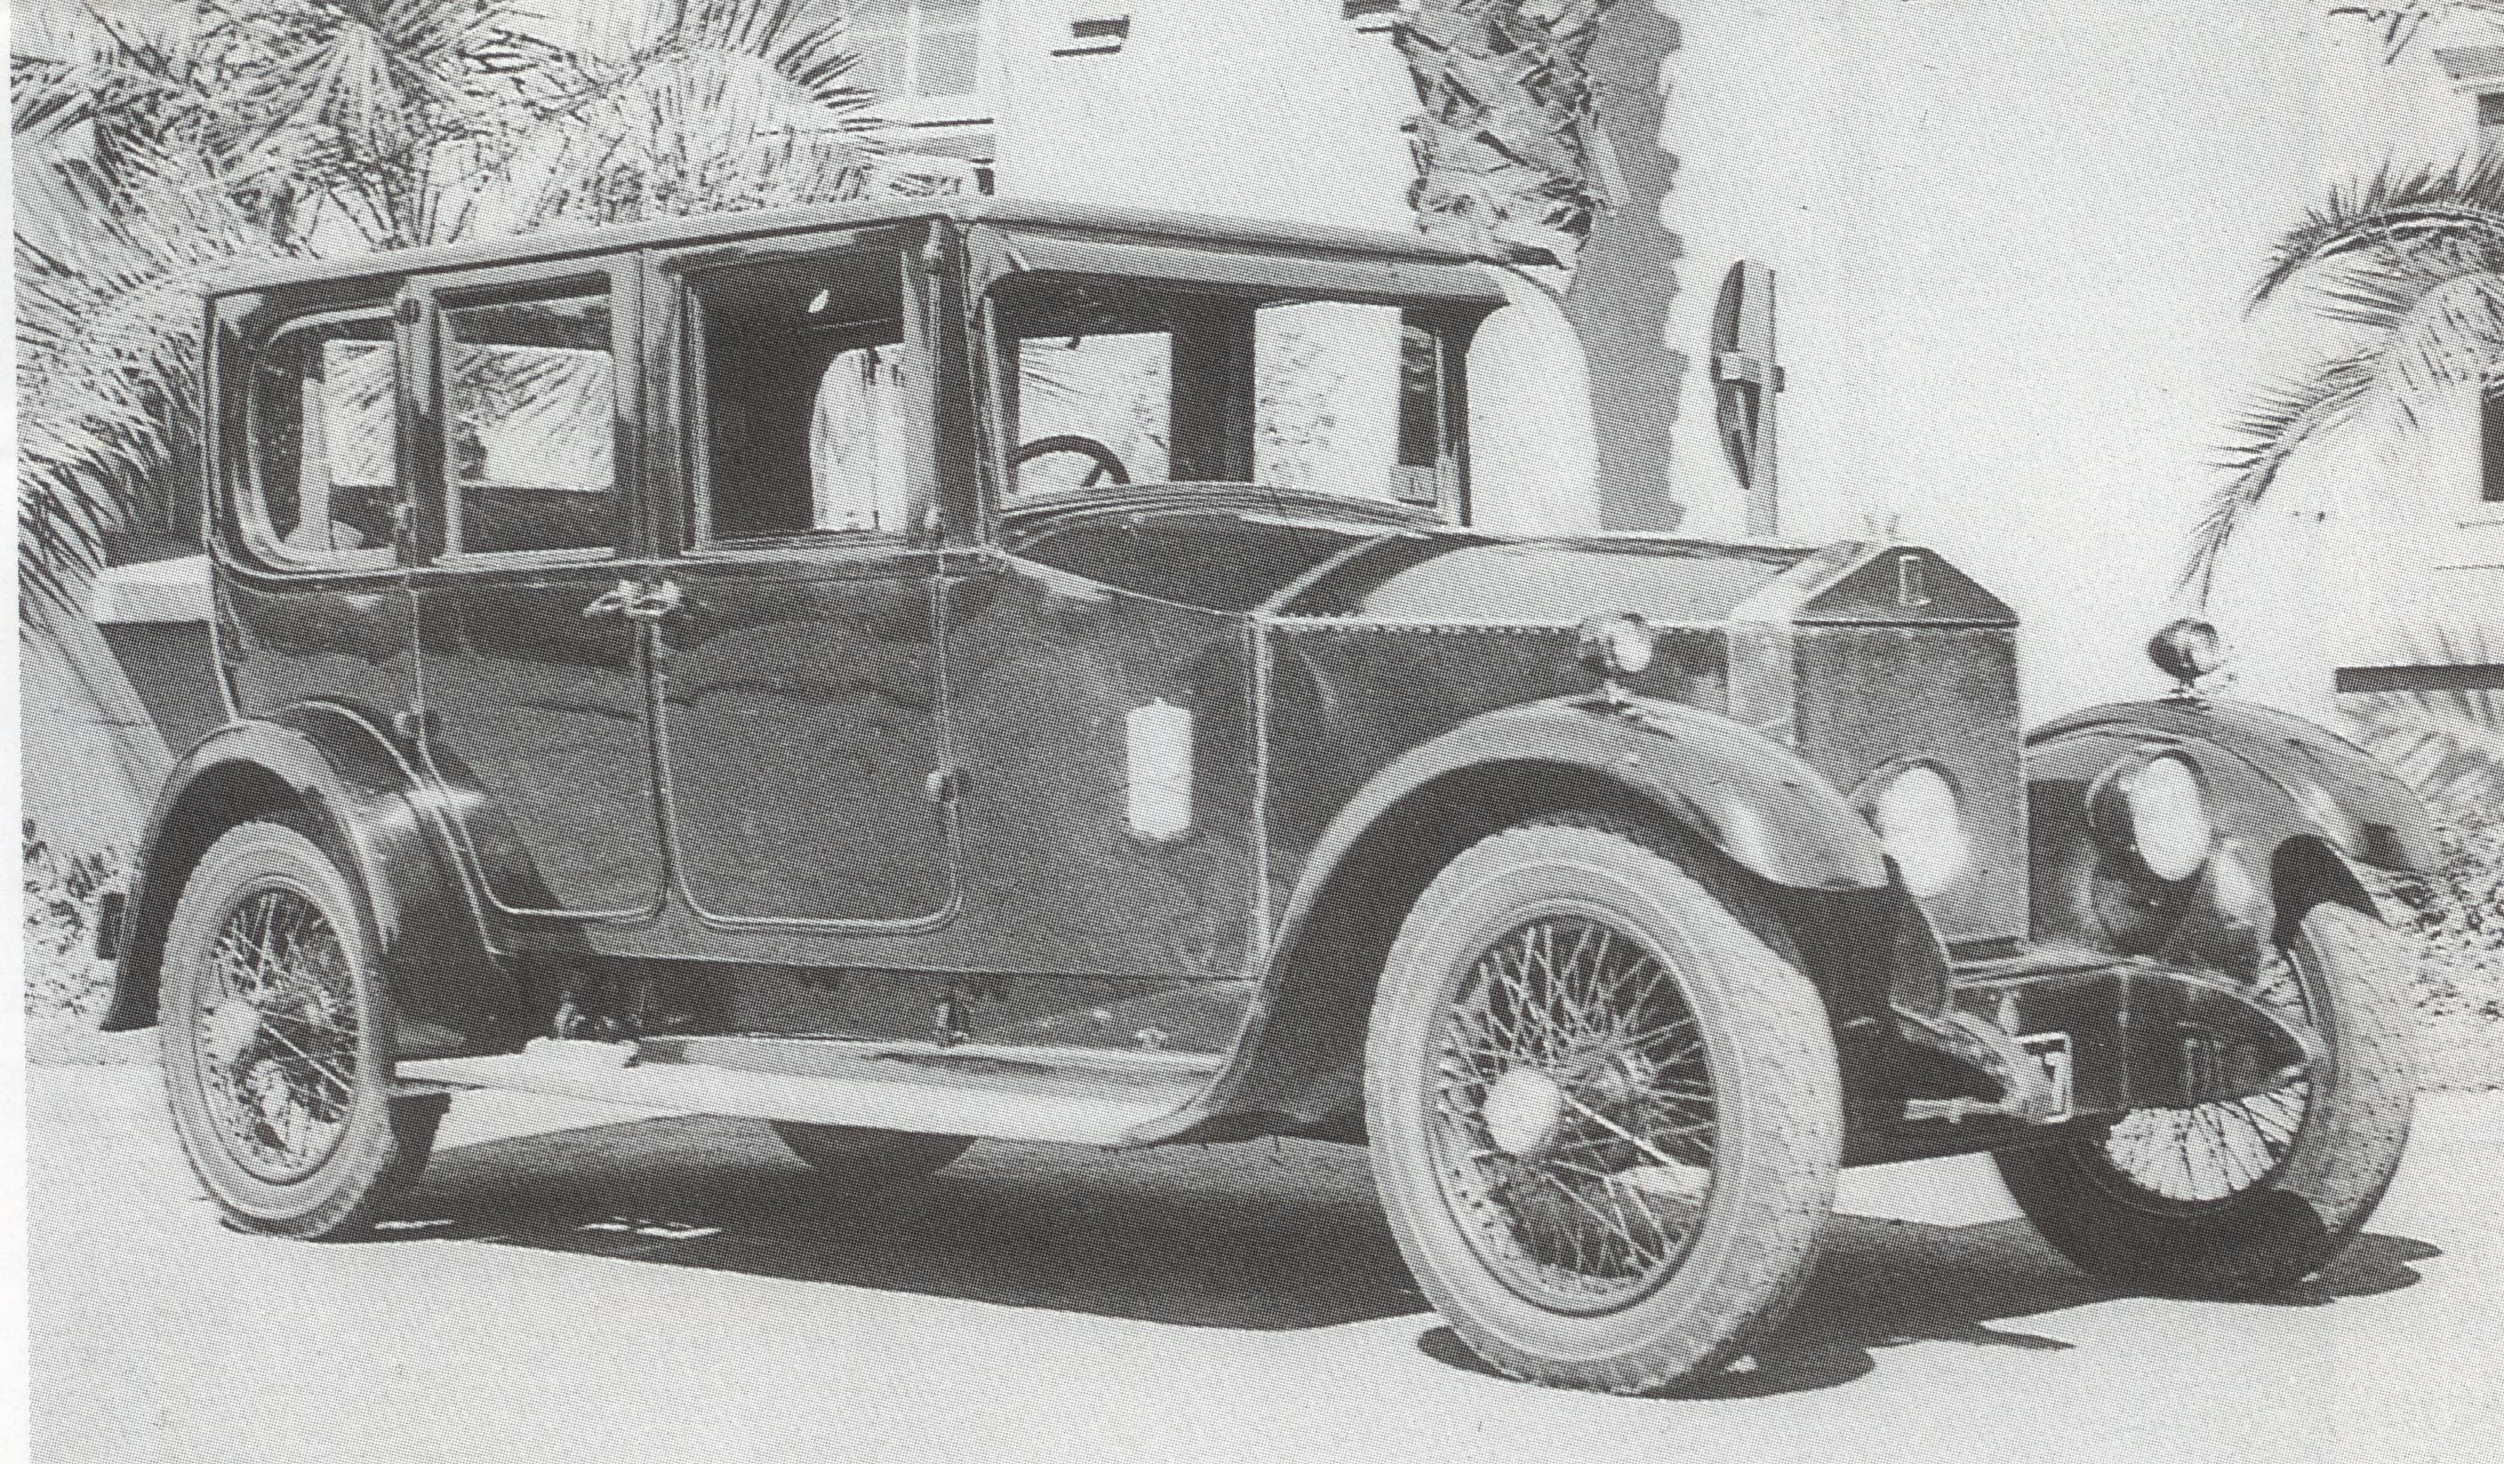. c1937
In 1932 the engine was overhauled with the fitting of a new cylinder block.
In 1936 a new top and bottom half of the crank case was fitted as apparently the legs were prone to break off as a result of the twisting of the chassis.
It seems that Col.Arnott sold the car in 1937 however shortly after, the body was modernized, by rebuilding from the waist up (body no 4). Again the original instrument board and scuttle was retained. I suspect that Properts carried out the work as it closely resembled another Twenty that Properts had rebodied
.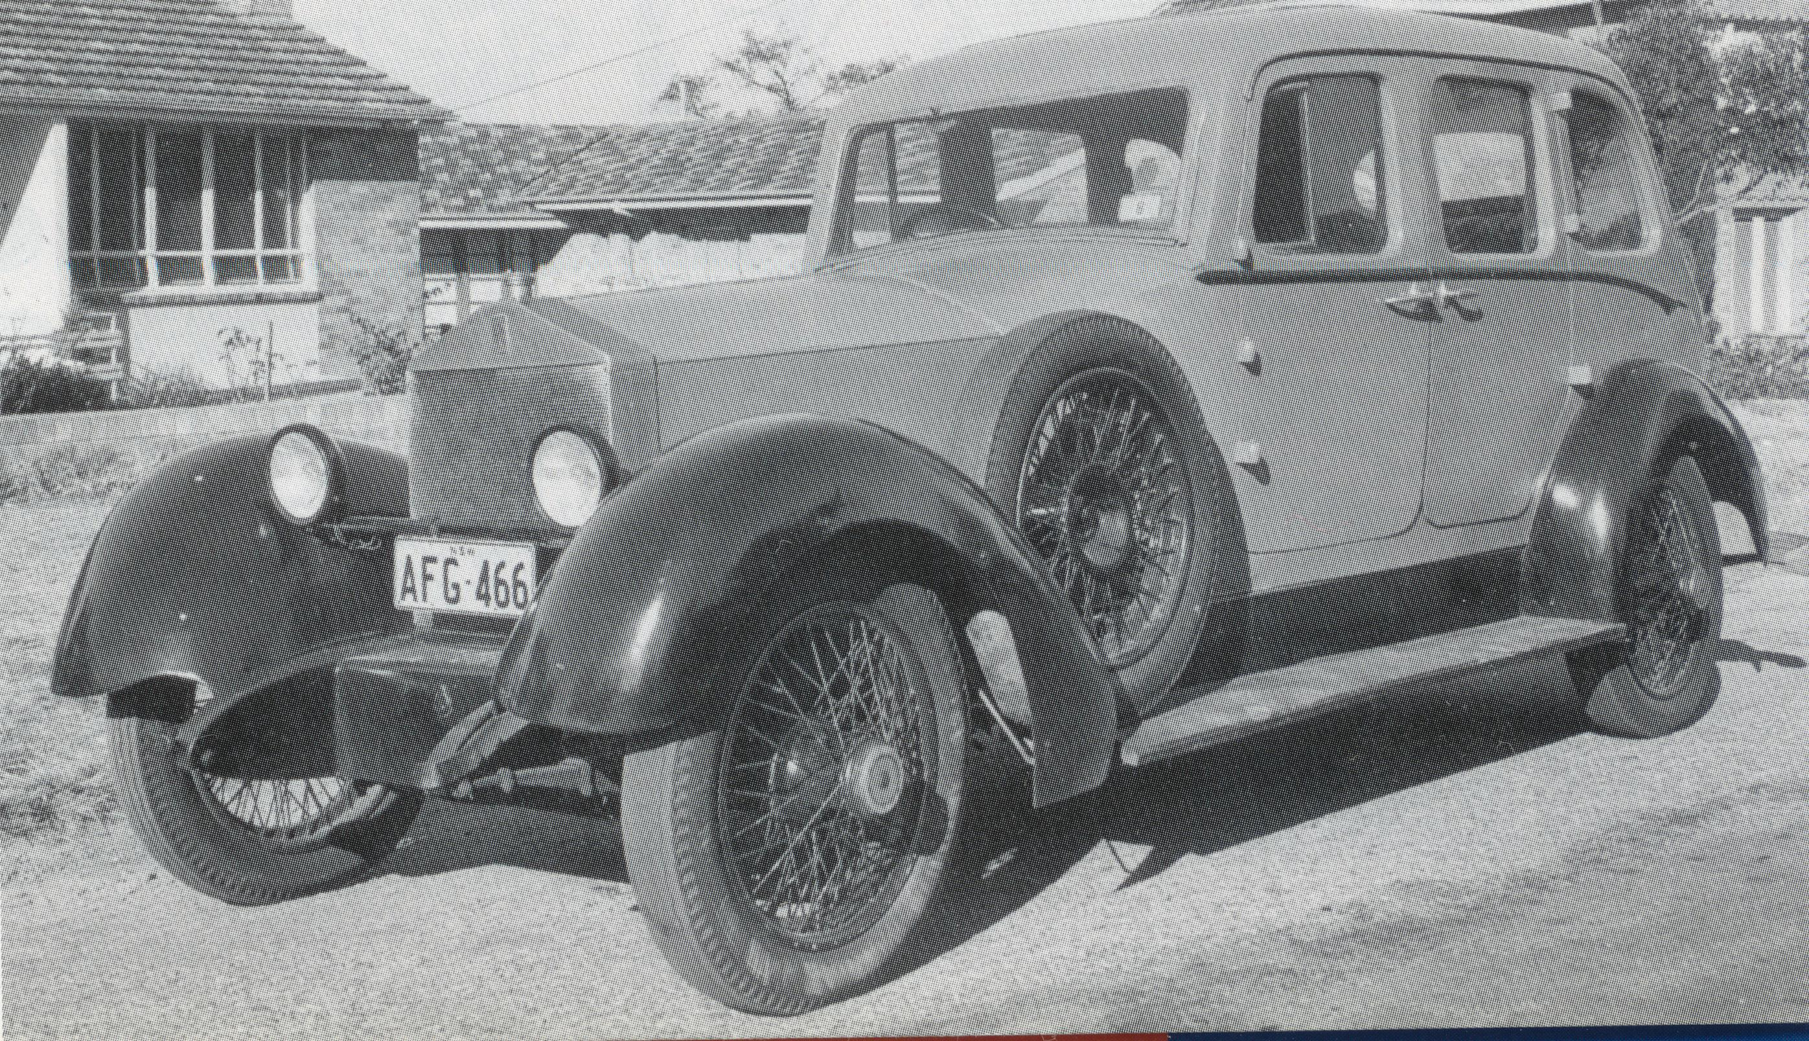c1957
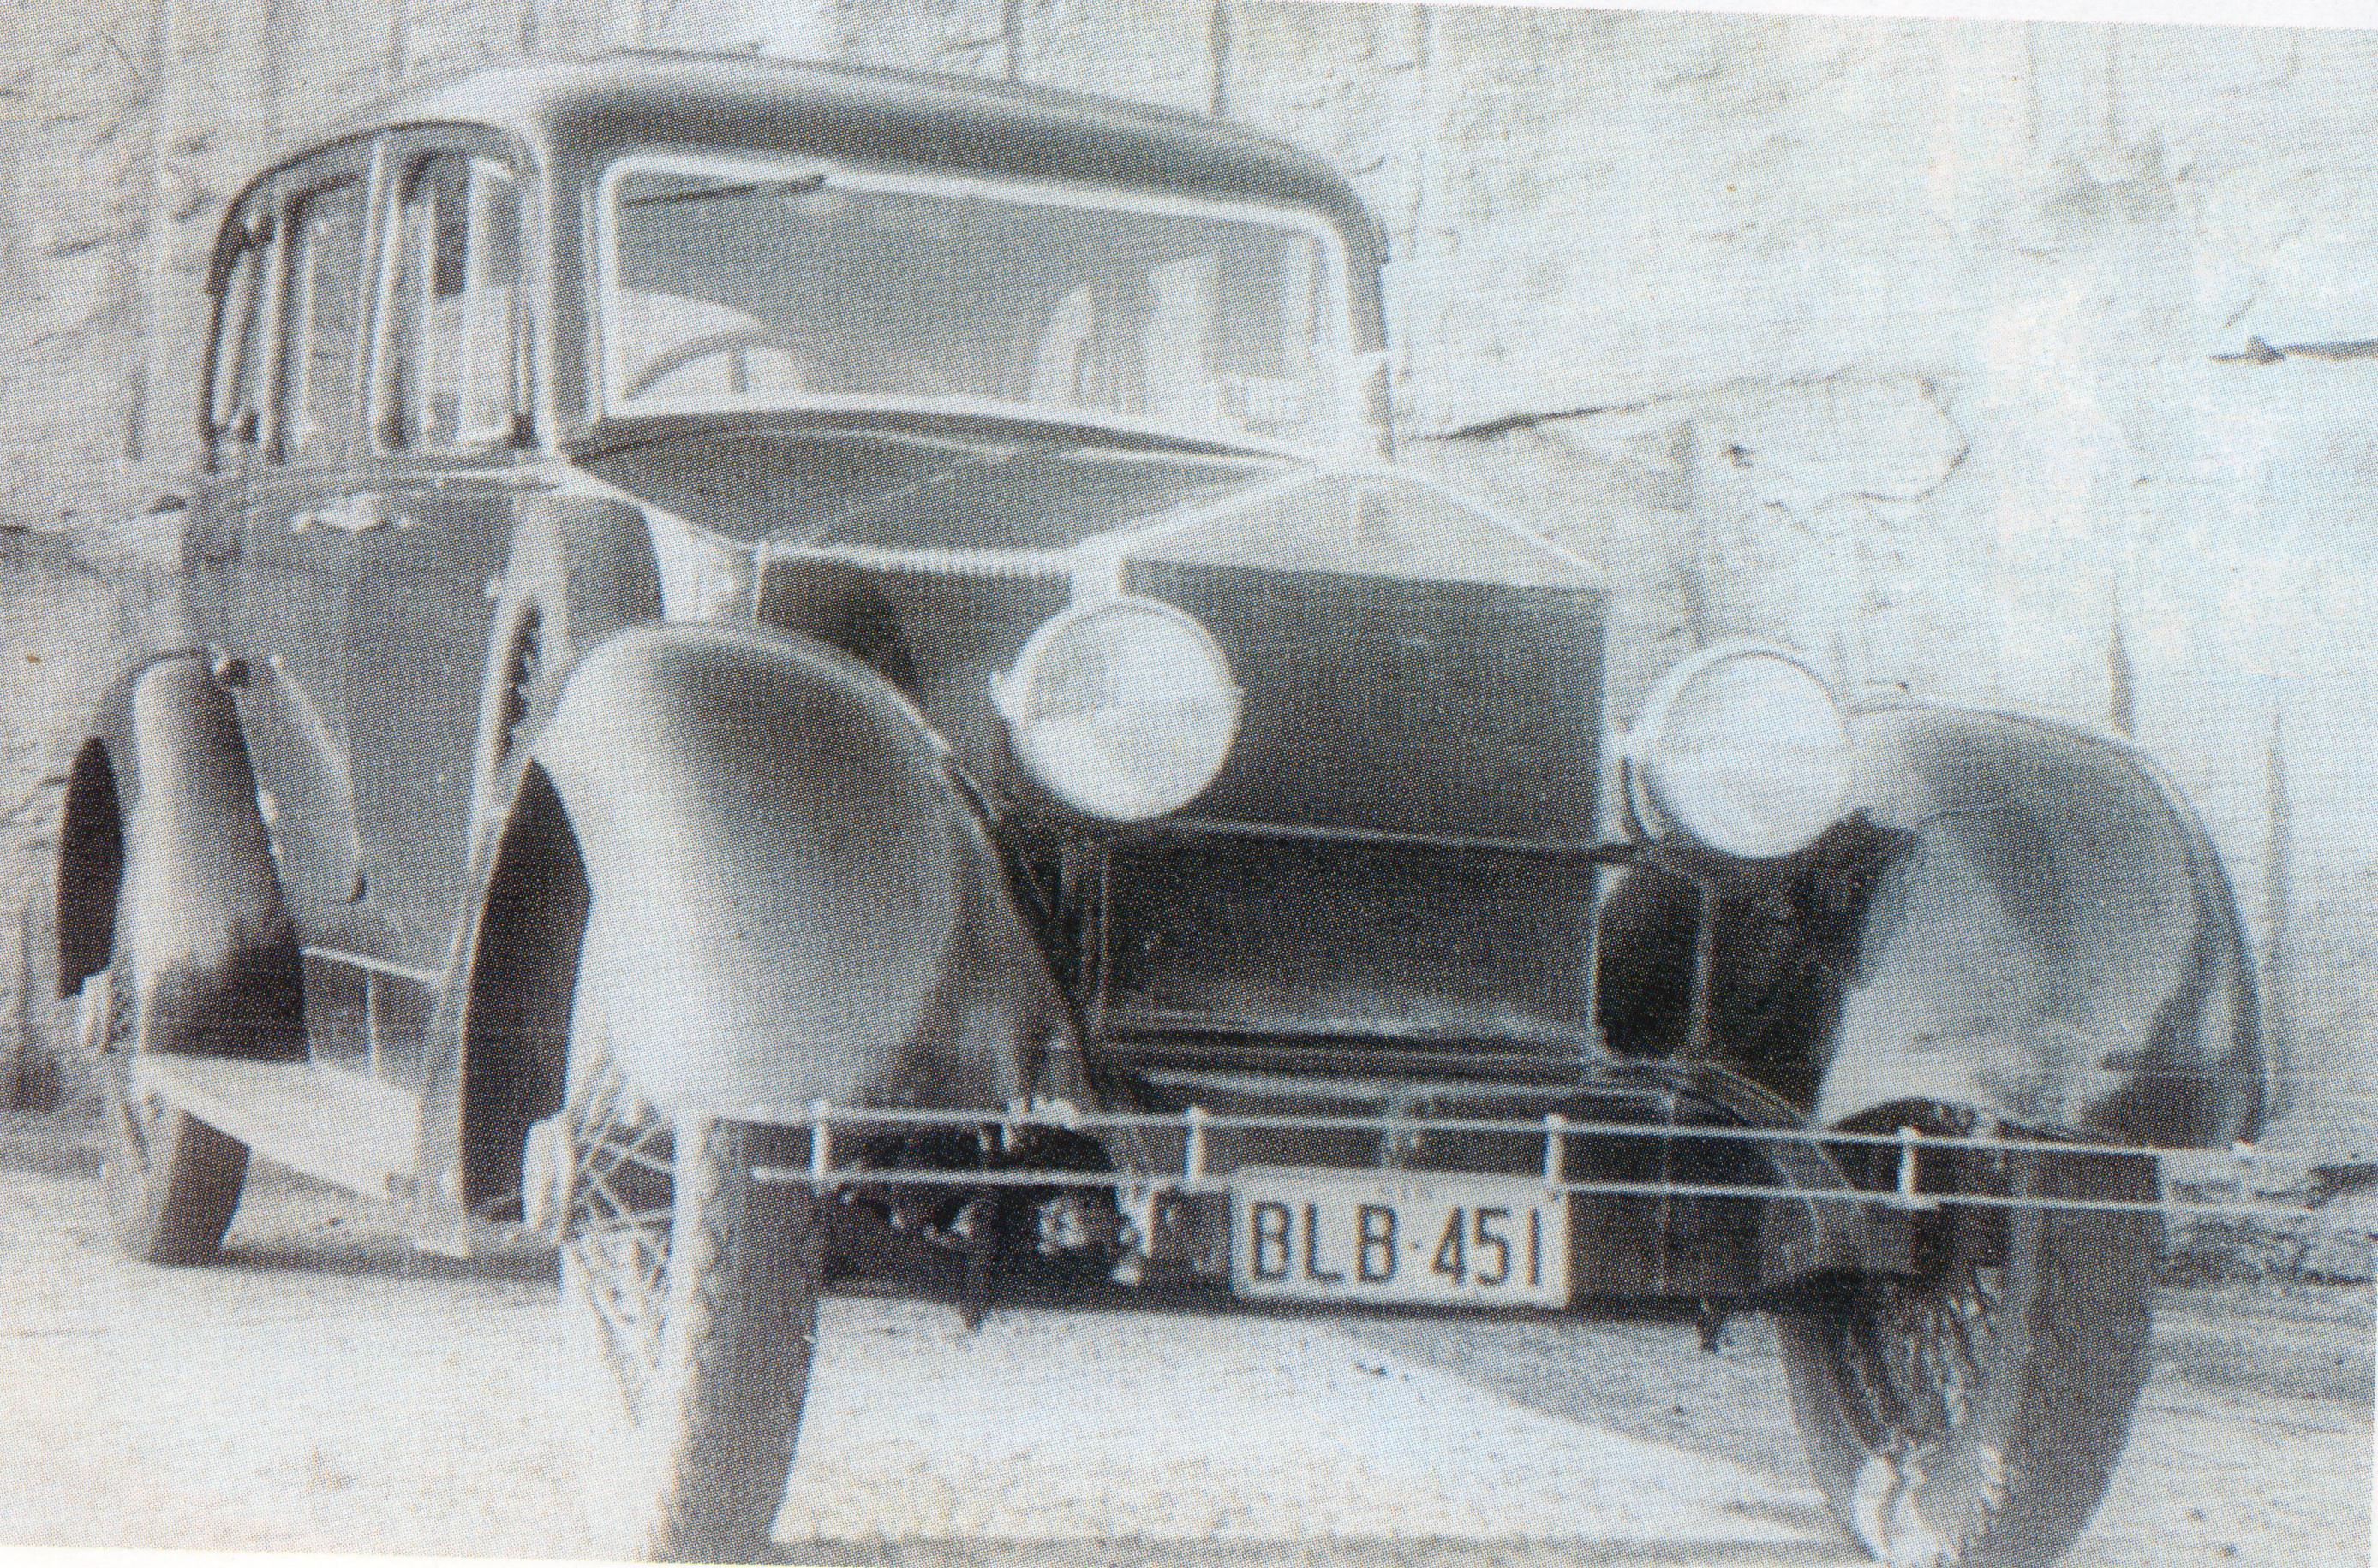c1959
It was in this ugly guise that I bought the car in 1959. The records are silent on repairs during the intervening years. It would seem that the car was laid up in the open during the War but was pressed back into service with little or no service shortly thereafter. It changed hands quite frequently including being raffled, which, perhaps says it all. When I bought it, it was worn out but was largely intact mechanically.
Within three weeks of acquisition, a piston broke which brought me to Bert Ward. He commenced a two year programme of mechanical overhaul followed by a complete engine rebuild in 1963. The block and head had to be repaired but even then Rolls Royce did supply many new parts from stock. These parts arrived by air as a previous lot sent for 42 G 1 ended up in Brazil, for some reason. During 1961 Bert decreed that the body was finished and I fitted the remnants of a Smith & Waddington tourer (1924) still retaining the original instrument board and scuttle ( body no 5). Don Appleby decreed the tourer falling to pieces in 1965 (so much for my coachbuilding efforts) so Bob Molyneux ( Diskon & Molyneux ) built the present tourer body utilizing parts from the earlier bodies including the instrument board but not the scuttle.(body no 6).
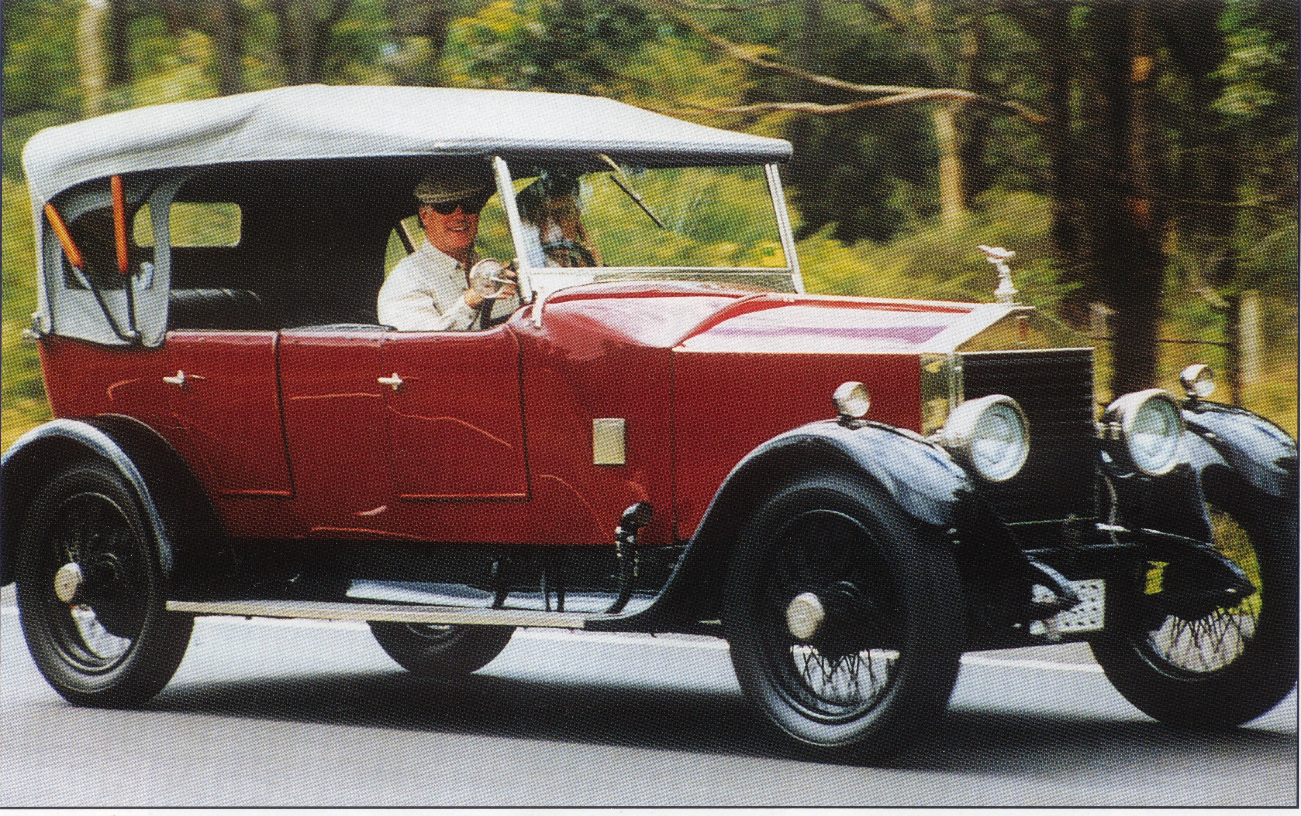c1993
Bob had worked for Smith & Waddington during the 1920’s and had actually worked on RR 20HP cars there, so his involvement was very appropriate. The colour scheme chosen was the car’s original scheme. .
Preventative maintenance was carried out over the intervening years including the fitting of a new first gear, king pins (twice), brakes (twice), clutch , rebuilt steering box (twice) By 1996 the engine was certainly worn out and was scheduled for an overhaul. Shortly before the due date in June 1996 the car was involved in another serious accident this time resulting in the obstructing car ending up 15cm narrower than designed. Unfortunately the impact bent the chassis of the Twenty which had to be largely dismantled in order to effect repairs. Brian McMillan carried out this task and refurbished the bodywork including rebuilding the front mudguards, re-plating the bright work except the radiator shutters which were painted black. In the meantime Ralph Appleby and Bob Murphy rebuilt the engine using now available new parts including cylinder block and head.
In 1999 the rear axle was dismantled to attend to a serious oil leak. It was found that the original ratio of 13x60 had been changed to 11x50 probably early on and I took the opportunity to increase the ratio higher to take advantage of the lighter body now fitted. The new ratio has made driving the car significantly easier particularly regarding gear changing. The oil leak proved very difficult to remedy, however the problem was solved by copying the Silver Cloud/S1 seal arrangement.
42 G 1 is now probably in as good a condition as it has ever been. It is certainly almost as Sir Henry originally designed the model. The car has covered a million miles, not that anyone believes it, but that does not alter the truth. It is unique in that it has been maintained by the RR agents for most of its life and in particular by the Applebys, Alf then his son Don and currently grandson Ralph as well as Bert Ward who worked on it before the War, and who supervised its post war mechanical overhaul. Indeed Alf and Bert collected it from the wharf when it was unloaded from the ‘S S Diogenes’.
I suspect that more than the price of ten Fords (the cost of a Twenty tourer in 1923) has been spent on maintenance over the 80 years of 42G1’s life, however, its survival and continuous service is remarkable.

