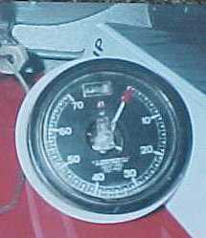1922 –25. Series A- F Includes part Series F which are 4wb

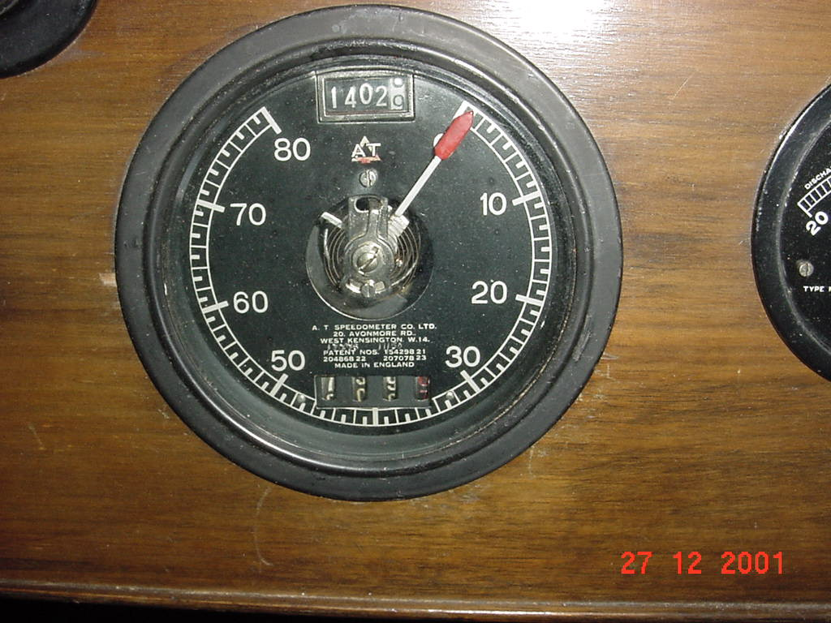

1925-1927 Series G- J 80MPH with tripmeter; 10,000 odometer

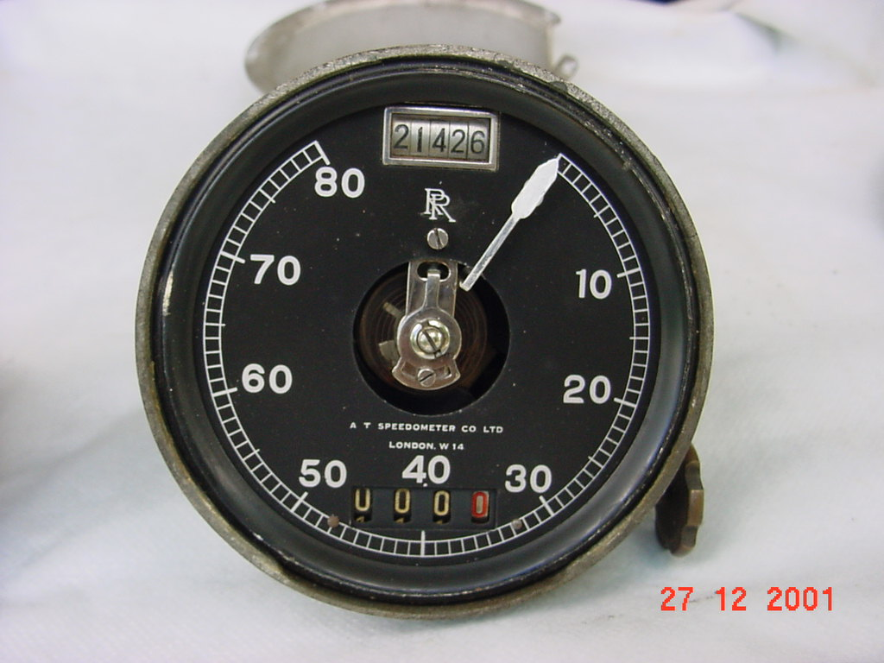
- Series M- ‘40’ above tripmeter; RR below 100,000 odometer
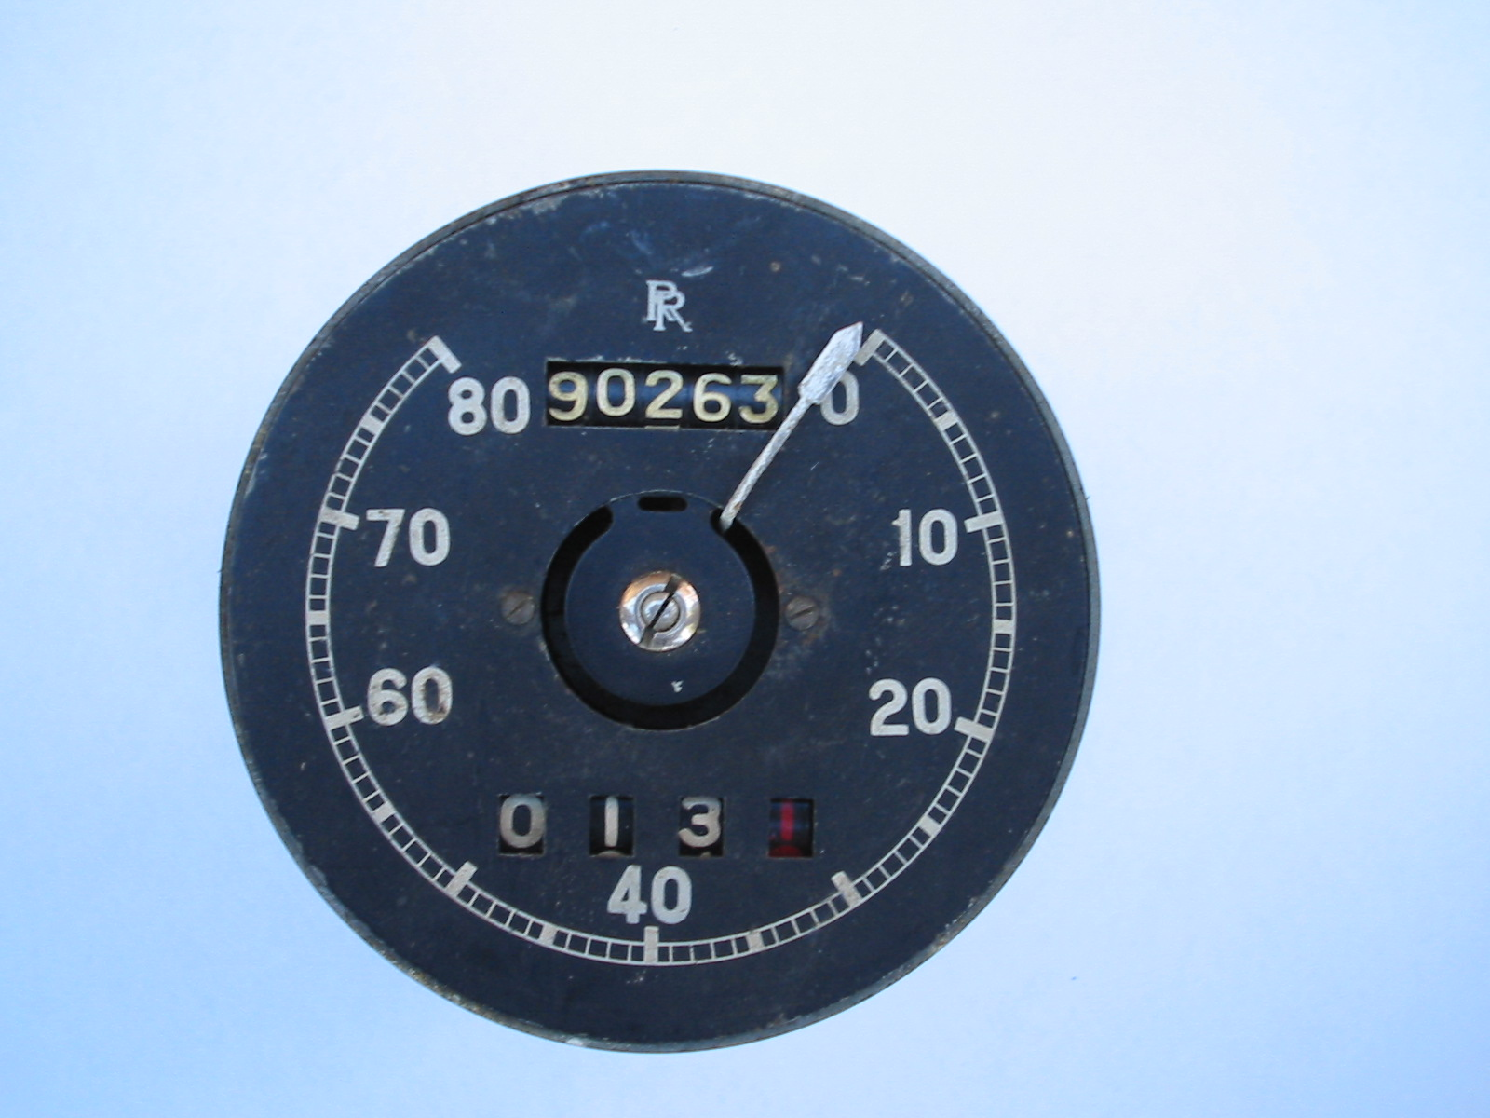
1929 - ’40’ below tripmeter, no ’30’ nor’50’; RR above 100,000 odometer
(relocated tripmeter & odometer)

